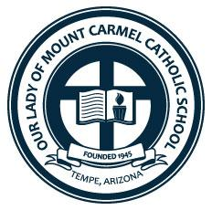
Our Lady Mount Carmel Preschool
2121 S. Rural Rd.
Tempe, AZ 85282

September 26, 2021
Dear Supporter,
Our Lady of Mount Carmel Catholic School was established in Tempe, Arizona in 1945. During this time, Our Lady of Mount Carmel has been a productive and impactful partner to our community providing education, ministry, and support through our school and Parish. Each year, throughout our various ministries, our volunteers put in 1,000+ hours of volunteer time toward our mission. As our community grows, so does its needs. In order to continue our important work, we are seeking to raise funds through our fundraising event. The overall mission at Our Lady of Mount Carmel is to pray, serve, give, and connect with our community. Please consider supporting our dedication and mission through our Night to Soar Gala fundraising event.
This year, Our Lady of Mount Carmel is proud to announce its 3rd Annual Night to Soar Gala. This is an adult ticketed semi formal event featuring cocktails, charcuteries, silent and live auctions, as well as other fundraising activities. It will be held on November 6th, 2021 from 6– 9pm.
Our goal is to provide an opportunity to come together to support our mission and community engagement, while at the same time advancing our efforts through fundraising. We invite you to connect with us as we advance our mission and provide a meaningful impact to our community with your generous help. We are seeking donations for use in our auctions to further our cause. All donations are tax deductible and receipts will be provided upon request.
In recognition of a donation, your business will be listed in the Our Lady of Mount Carmel parish bulletin, school newsletter, and social media accounts. These recognitions will reach 4,000+ families in our community.
Scan the QR code to go directly to our Gala website to buy tickets, donate or sponsor today!
Sincerely,
Ashley Hall
Director of Development and Stewardship
OLMC School and Parish
ashley@olmctempe.com 480-967-8791
OLMC Tax ID: 36-4643600

